What’s the project about?
As of now, the aim of this project is to help instructors achieve their intended course outcomes in the smoothest way possible, or realign goals if needed using insights from students’ data.

Objective:
The focus for this semester is to get a web-based dashboard ready displaying the metrics that are most valuable to the instructors and perform a pilot study to analyze the impact of this intervention in saving the instructors’ time.

Data:
For now, we have the discussion forums data from Piazza for a previous iteration of the CS6601: Artificial Intelligence course taken by Dr. Thad Starner.

How are we approaching it?
Our focus currently is on 2 aspects of a popular framework in Education Research called the Community of Inquiry framework: Cognitive Presence and Social Presence. Cognitive Presence is related to how cognitively engaged a learner is. For quantifying it, here’s a coding mechanism:
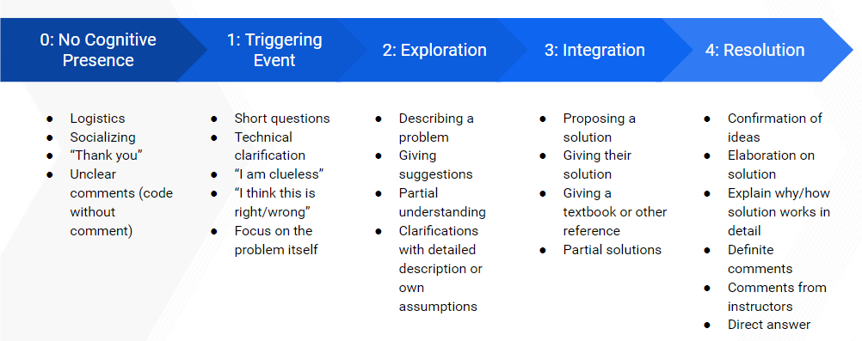
Currently, we have some manually labeled data where each comment or post in the forum is assigned one of these 5 labels. Based on this labeled data, we have created a machine learning model to automatically label unlabeled comments. The reasoning behind this quantification is that it allows us to observe the overall trends of the class in a much saner and comprehensible way. And then whenever we find interesting data points, we can always look deeply into the respective threads to perform a qualitative analysis. The other aspect is social presence, where the focus is on observing patterns of communication in the student community. For example, how does the content of high-volume contributors in the forums differ from occasional contributors? How does their class performance vary? Are there certain connections developing within these forums, like a few students having a high response rate on each other’s posts, etc.? How do instructor contributions influence the cognitive presence and sentiment of students? How does this sentiment change over time as the course progresses? etc.

What’s our current progress?
For the cognitive presence modeling, our accuracy is around 80-90% on the data we have right now. Not perfect, but good for a start. We will be working on getting that up this semester. For the social presence, we have network graphs and some preliminary analysis on some interesting patterns observed on this data but no predictive model as of now. We do have a list of questions we’d like to explore answers to on that though. In terms of the dashboard itself, we have prototype designs and a working js code. For details, can connect with Sambhav who was working on the front-end till the last sem. Regarding the backend part, we are at a stage where given we can get data in our SQL database, we can show the outcomes from our machine learning models on our dashboard. As of now, we’re trying to connect and get Dr. Starner’s approval for a pilot study this semester where we can fetch data in real-time from Piazza API, populate the database, run the models for cognitive presence scores, sentiment analysis, and other metrics relevant to the instructor team and display insights in an interactive dashboard. So, integrating with Piazza API will be our first action item for the backend team.

What are our targets this semester?
It will be mutually decided, taking into account the newer members of the team, but broadly the following:
- Web-Dev:
  - Backend: Integrate with the Piazza/Ed API
  - Frontend: Design the front-end interaction, display the graphs with the metrics obtained from the backend and Data Science team. What to show will be based on user study, which involves interviewing instructors.
- Data Science:
  - Build methods/functions/models to calculate the metrics suggested by instructors from the data we have

Who’s responsible for what?
- Malav is taking care of the cognitive presence model and the sentiment analysis model. So, for Machine Learning related parts, he’s the guy.
- Aanya has been taking care of our backend, so for the database, connecting with front-end, connecting with the ML model scripts, she’ll help you.
- Nidhi has been actively looking at user research, identifying metrics, relationships with course outcomes, etc. So, if you need answers on the ‘why’ of what we’re looking at, feel free to bug her and see what happens :-p
- Gautam has been contributing to user research and partly web-dev. He’ll be more engaged with the web-dev team this sem.
- Pratik is a free-floating resource. Anything about the project you’re struggling with, and need more clarity after interacting with the other folks, ping him and he’ll connect.

